Apply filters to SQL queries

Project description
In this project, I acted as a security professional at a large organization, tasked with investigating potential security issues involving employee machines and login attempts. The project focused on querying and filtering data from two relational tables — employees and log_in_attempts — to identify suspicious patterns, department-specific activities, and potential risks.
Using SQL filtering techniques, I applied a combination of WHERE, AND, OR, NOT, and LIKE clauses to retrieve relevant records and support the investigation. The goal was to extract actionable insights to help the organization enhance its cybersecurity posture.

Retrieve after hours failed login attempts
SELECT *
FROM log_in_attempts
login_time > '18:00' AND success = False;

Explanation:

WHERE starts the filter conditions.
login_time > '18:00' filters for login attempts after 6 PM.
AND combines conditions.
success = FALSE filters failed login attempts (if your DB uses Boolean, otherwise use success = 0).

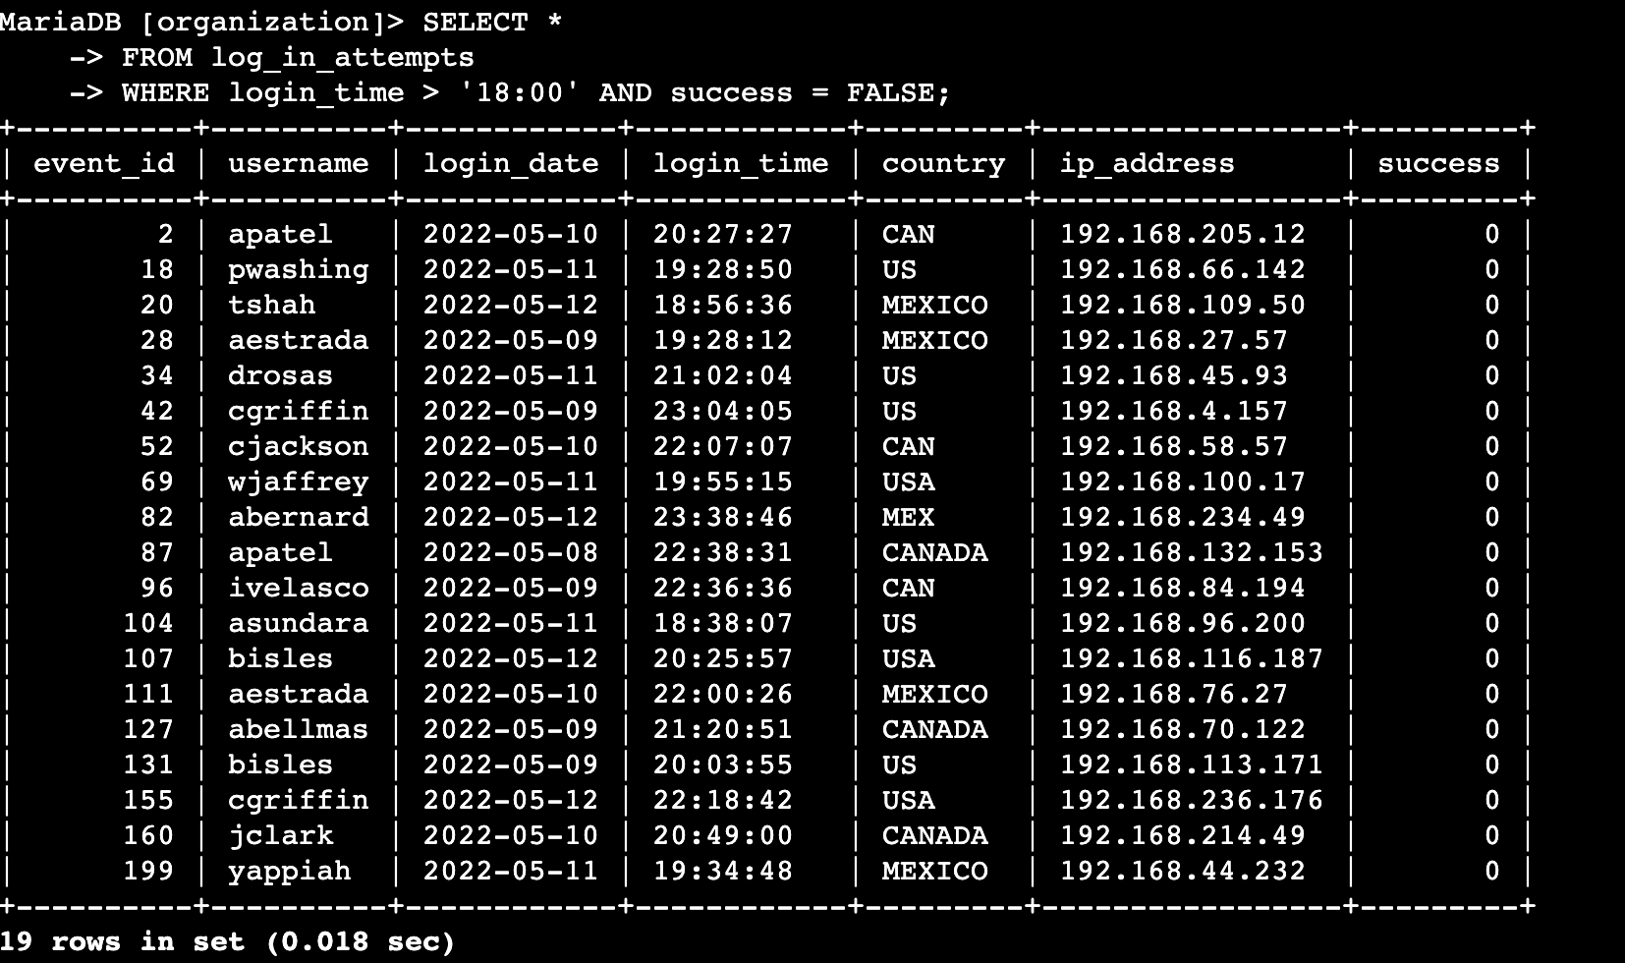

Retrieve login attempts on specific dates:
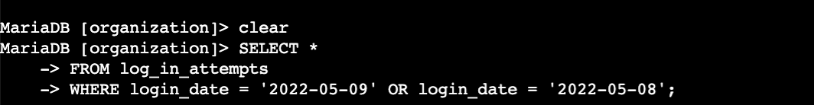
SELECT *
FROM log_in_attempts
WHERE login_date = '2022-05-09'
OR login_date = '2022-05-08';

Explanation:
- SELECT *: This part tells the database to retrieve all columns from the records that match the filter.
- FROM log_in_attempts: Specifies that we want to query the log_in_attempts table, which presumably contains data about login attempts.
- WHERE login_date = '2022-05-09' OR login_date = '2022-05-08': This filter selects rows where the login_date column is either '2022-05-09' or '2022-05-08'.
  - The OR operator means that if either condition is true for a record, it will be included.
  - So, this query fetches all login attempts that happened on May 8th or May 9th, 2022.

Retrieve login attempts outside of Mexico
SELECT *
FROM log_in_attempts
WHERE NOT country LIKE 'MEX%';

Explanation:
SELECT *: Retrieves all columns from the matching records in the table.
FROM log_in_attempts: Specifies the table log_in_attempts to query from, which contains login attempt data.
WHERE NOT country LIKE 'MEX%': This condition filters records where the country column does NOT start with 'MEX'.
- The LIKE 'MEX%' pattern matches any value in the country column that starts with the string 'MEX' — for example, 'MEX', 'MEXICO', or any other country code beginning with those letters.
- The NOT operator reverses this filter, so the query returns all records where the country is anything except those starting with 'MEX'.

Retrieve employees in Marketing
SELECT *
FROM employees
WHERE department = 'Marketing'
AND office LIKE 'East-%';
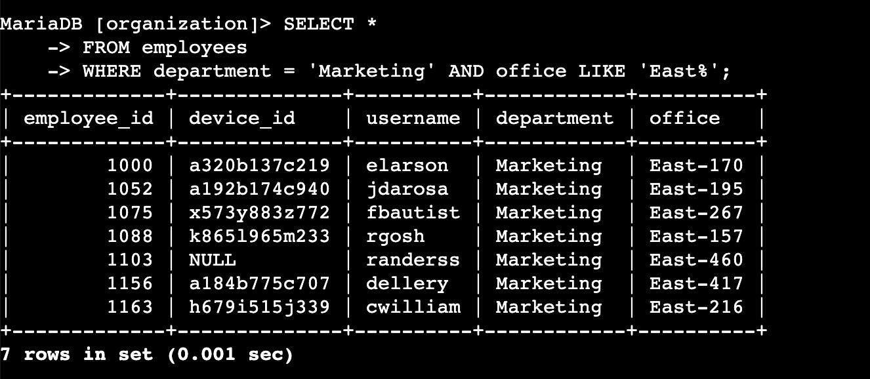

Explanation:
SELECT *: Retrieves all columns from the matching employee records.
FROM employees: Specifies that the data is being queried from the employees table.
WHERE department = 'Marketing': Filters the records to only include employees who work in the Marketing department.
AND office LIKE 'East-%': Further filters those Marketing employees to only those whose office value starts with 'East-'.
- The % is a wildcard that matches any sequence of characters after 'East-'. For example, 'East-170', 'East-320', etc.

Retrieve employees in Finance or Sales
SELECT *
FROM employees
WHERE department = 'Finance'
OR department = 'Sales';
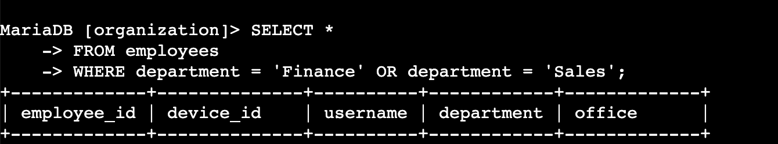

Explanation:
- SELECT *: Retrieves all columns for each matching record in the result.
- FROM employees: Specifies the table employees to fetch data from.
- WHERE department = 'Finance' OR department = 'Sales': Filters the records to include employees who belong to either the Finance department or the Sales department.
  - The OR operator means that if either condition is true (department is Finance or department is Sales), the record will be included.

Retrieve all employees not in IT
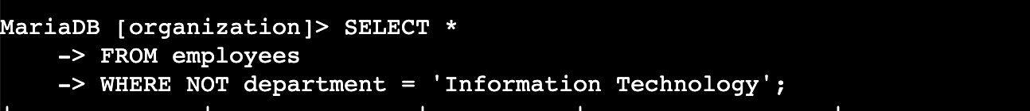
SELECT *
FROM employees
WHERE NOT department = 'Information Technology';

Explanation:
- SELECT *: Retrieves all columns from the matching employee records.
- FROM employees: Specifies the employees table to query.
- WHERE NOT department = 'Information Technology': Filters the records to include all employees whose department is NOT 'Information Technology'.
  - The NOT operator negates the condition, so any employee whose department is anything other than 'Information Technology' will be selected.

Summary
Throughout the project, I successfully used SQL filters to isolate login attempts outside of Mexico, find employees in particular departments and locations, and identify failed login attempts after business hours. By leveraging LIKE with % wildcards, I searched for patterns in office locations and country codes. I also filtered data for specific dates and times and combined multiple conditions using AND and OR to refine results. Additionally, I used the NOT operator to exclude certain departments from queries, helping the security team focus on relevant employee groups.

